**Academic Year: 2024-2025 Name of Student:Diya Thakkar**

**Semester: V Student ID:22107040**

**Class / Branch: TE/CSE-DS Date Of Performance:8/10/24**

**Subject**: **DWM Lab Date Of Submission:8/10/24 Name of Instructor: Prof. Archana Kotangale**

**Experiment No.10**

**Aim:**- Implementation of Page Rank algorithm in python.

**Program:**

import matplotlib.pyplot as plt

import networkx as nx

import pandas as pd

import scipy as scipy

G = nx.DiGraph()

[G.add_node(k) for k in ["A", "B", "C", "D", "E", "F", "G"]]

G.add_edges_from([('G','A'), ('A','G'),('B','A'),

('C','A'),('A','C'),('A','D'),

('E','A'),('F','A'),('B','D'),

('D','F')])

pos = nx.spiral_layout(G)

nx.draw(G, pos, with_labels = True, node_color="red")

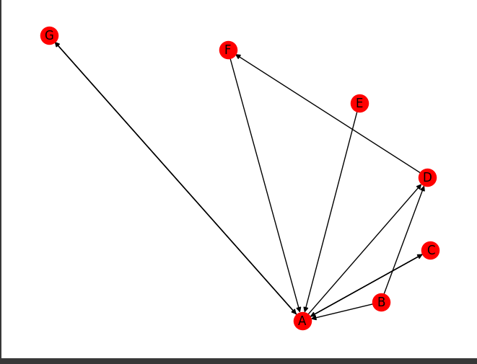

pr1 = nx.pagerank(G)

print(pr1)

nx.draw(G, pos, nodelist=list(pr1.keys()), node_size=[round(v * 4000) for

v in pr1.values()],

with_labels = True, node_color="red")

OUTPUT:

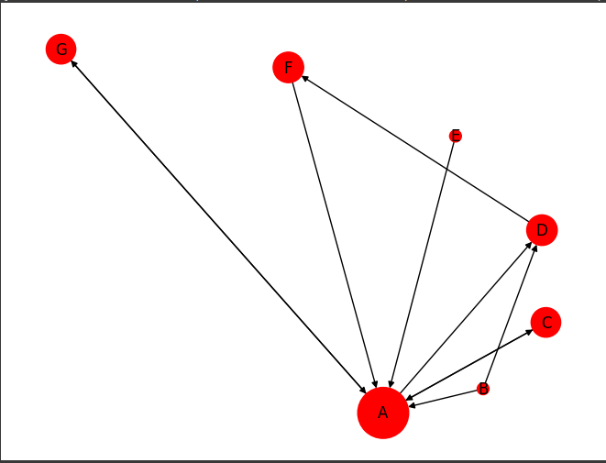{'A': 0.40001520046189115, 'B': 0.021428571428571432, 'C': 0.1347663991011727, 'D': 0.14387354195831553, 'E': 0.021428571428571432, 'F': 0.1437213165203047, 'G': 0.1347663991011727}